CS 255 System Design Document Template

This template lays out all the different sections that you need to complete for Project Two. Each section has guidance to prompt your thinking. You will need to continually reference the interview transcript as you work to make sure that you are addressing your client’s needs. There is no required length for the final document. Instead the goal is to complete each section based on what your client’s needs are. Remove this note when you are finished, and replace all bracketed text with the relevant information.

UML Diagrams

UML Use Case Diagram
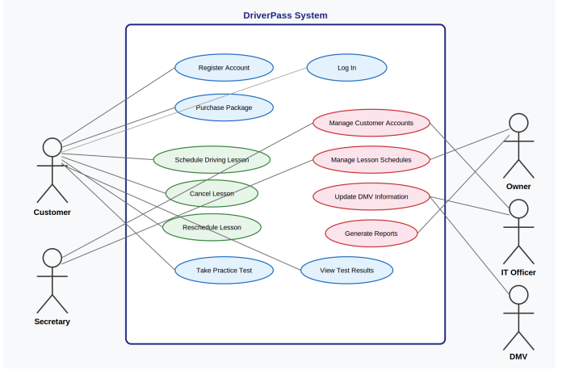

UML Activity Diagrams
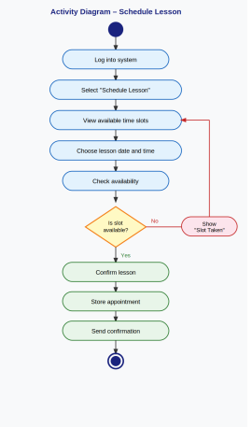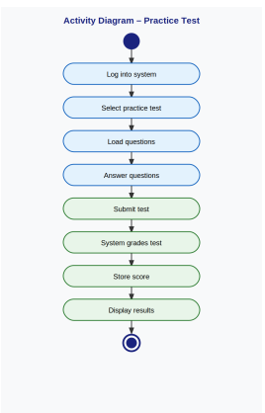

UML Sequence Diagram

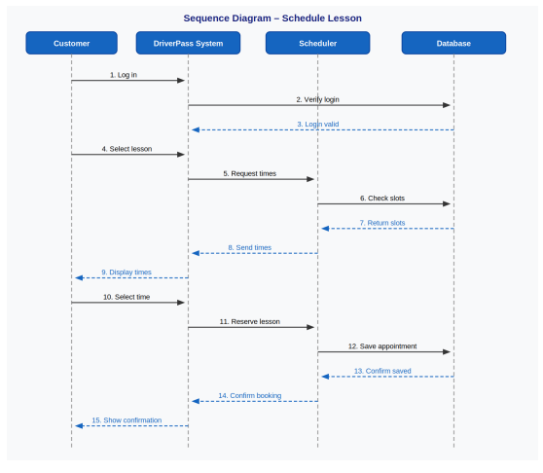

UML Class Diagram
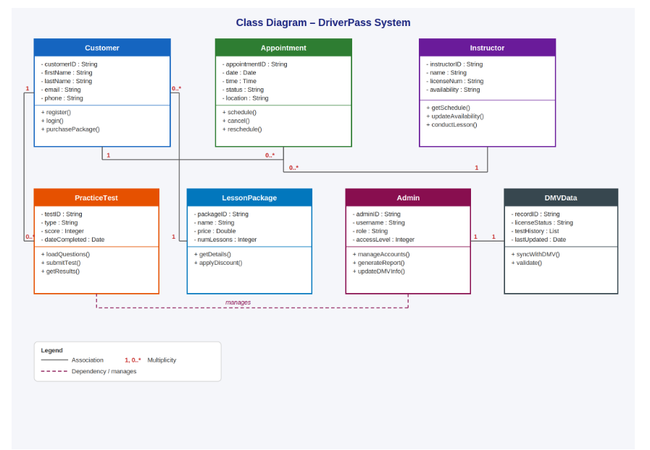

Technical Requirements
The DriverPass system will need both hardware and software to support customer access, scheduling, online testing, and administrative functions. On the hardware side, the system should run on a secure server that can handle stored user data, lesson scheduling, and online practice tests. Customers and employees should be able to access the system from desktop computers, laptops, tablets, or mobile devices with an internet connection. Since the business depends on customers accessing the platform online, a reliable internet connection and cloud based, or web hosting environment will be necessary.
On the software side, the system should support a web based application that can run through common browsers such as Chrome, Edge, or Safari. A database management system will be needed to store customer accounts, appointment details, lesson packages, and test results. The system should also include login protection, password security, and role based access so only authorized users can reach certain features. For development and planning, tools such as Lucidchart can be used for system modeling, while a database platform and web development tools will support implementation. Overall, the system infrastructure should be designed to be secure, reliable, easy to maintain, and flexible enough to support future DMV updates and business growth.

